**LAPORAN PRAKTIKUM**

**PEMROGRAMAN 2**



**Oleh:**

Muchamad Lutfi Maftuh

NIM. 19537141023

**PRODI TEKNOLOGI INFORMASI**

**JURUSAN PENDIDIKAN TEKNIK ELEKTRONIKA DAN INFORMATIKA**

**FAKULTAS TEKNIK**

**UNIVERSITAS NEGERI YOGYAKARTA**

**2020**

1. **Soal 9.1**
2. UML Diagram

|  |
| --- |
| Rectangle |
| height: double  width: double |
| Rectangle()  Rectangle(w: double, h: double)  getArea(): double  getPerimeter(): double |

1. Run program

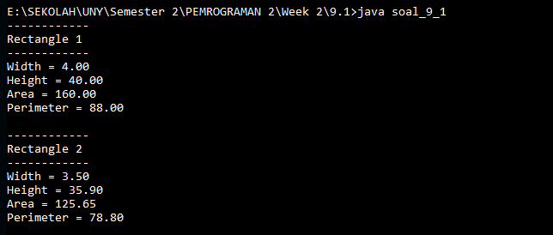

1. **Soal 9.2**
2. UML Diagram

|  |
| --- |
| Stock |
| symbol: string  name: string  previousClosingPrice: double  currentPrice: double |
| Stock(name: string, symbol: string): double  getChangePercent(): double |

1. Run program

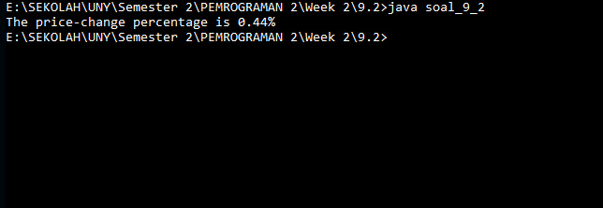

1. **Soal 9.3**
2. UML Diagram

|  |
| --- |
| cobaDate |
| date: Date |
|  |

1. Run program

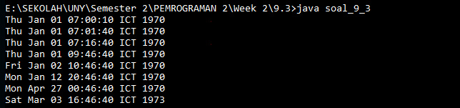

1. **Soal 9.7**
2. UML Diagram

|  |
| --- |
| Account |
| - id: int  - balance: double  - annualInterestRate: double  - dateCreated: Date |
| Account()  Account(id: int, balance: int)  getId(): int  getBalance(): double  getAnnualInterestRate(): double  getDateCreated(): Date  setId(id: int): void  setBalance(balance: double): void  setAnnualInterestRate(annualInterestRate: double): void  getMonthlyInterestRate(): double  getMonthlyInterest(): double  withdraw  deposit(total: double): void |

1. Run program

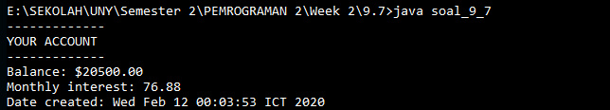

1. **Soal 9.8**
2. UML Diagram

|  |
| --- |
| Fan |
| SLOW: int = 1  MEDIUM:: int = 2  FAST: int = 3  - speed: int = SLOW  - on: boolean = false  - radius: double = 5  - color: string = “blue” |
| Fan()  getSpeed(): int  getOn: boolean  getRadius(): double  getColor(): string  setSpeed(speed: int): void  setOn(on: Boolean): void  setRadius(radius: double): void  setColor(color: string): void  toString(): string |

1. Run program

